ROYAL AIR PALADIN-SERIES INSTALLATION INSTRUCTIONS

The ROYAL AIR PALADIN SYSTEM is fairly simple to install in almost any ducting system. A skilled HVAC contractor can complete the installation properly in 30 – 45 minutes depending on whether additional air switches are required.

Our systems come in 120 VAC 60 Hz. and 220/230/240 VAC 50 Hz. For ease of installation you may want to order units with the same voltage requirements (120VAC or 220VAC) as your Air Handler.

For Electric Heat or Heat Pump furnaces you may want to get the 220 volt models to avoid needing additional blower relays.

STEPS TO INSTALLING YOUR PALADIN ROYAL AIR, AIR PURIFIER 220 VAC

1. First turn off the power supply to the furnace.

2. Remove Furnace Panel.

3. Wire the ground wire (green) from the PALADIN unit to the ground lug inside the furnace.
4. Then take the white wire from the PALADIN unit and attach it to the high voltage lug.
A. Make sure it is the lug to which the common side of the blower is connected. It is usually the white wire coming from the blower motor or the only lead from the blower motor going straight to the high voltage lug.

5. Connect the black wire from the PALADIN unit to the blower relay by attaching a spade connecter to the end of the black wire.
a. Blower relays used on the new furnaces today are circuit boards with small black solid state relays attach to the board. You will see the high speed black wire from the blower motor connected to it by a spade connector on the end of the wire.

6. Pull the wire from the blower motor off the relay and install a double spade connecter on the relay.

7. Reconnect both wires back to the relay. You are now ready to test the PALADIN ROYAL AIR, AIR PURIFIER.

TESTING THE PALADIN ROYAL AIR, AIR PURIFIER

1. Turn the power supply back on to the furnace.

2. Go to the thermostat and set the fan switch from the “auto” position, to the “on” position. This should make the blower come on.

3. Turn the knob on the PALADIN unit to its highest setting.

4. Now take a digital amp probe and clamp it around either the white or black wire from the PALADIN unit. It should read .01 amps and go to .00 amps when the blower cycles off or is turned off.

5. Replace your Furnace Panel. Installation is complete!

STEPS TO INSTALLING YOUR PALADIN ROYAL AIR, AIR PURIFIER 110 VAC

The 110 volt PALADIN unit can be used in a standard Electric Heat or Heat Pump furnace by using a separate blower relay. The 90-380 relay works well.

1. First turn off the power supply to the furnace.

2. Remove Furnace Panel.

3. Connect the white & green wires from the PALADIN unit to the ground lug.

4. Mount the 90-380 relay inside the electrical part of the furnace.

5. The 90-380 relay has six terminals label 1 thru 6
a. Connect a wire from any of the two high voltage lugs to terminal # 2
b. Connect the black wire from the PALADIN unit to terminal # 4
c. Connect a low voltage wire (24 volt) from the “G” terminal or green wire to the terminal # 1.
d. Connect a low voltage wire (24 volt) from the “C” terminal (known as common) to the terminal # 3.

6. You are now ready to test the PALADIN ROYAL AIR, AIR PURIFIER.

TESTING THE PALADIN ROYAL AIR, AIR PURIFIER

1. Turn the power supply back on to the furnace.

2. Go to the thermostat and set the fan switch from the “auto” position, to the “on” position. This should make the blower come on.

3. Turn the knob on the PALADIN unit to its highest setting.

4. Now take a digital amp probe and clamp it around either the white or black wire from the PALADIN unit. It should read .01 amps and go to .00 amps when the blower cycles off or is turned off.

5. Replace your Furnace Panel. Installation is complete!

PALADIN ROYAL AIR, AIR PURIFIER 110 VAC. INSTALLATIONS FOR GAS OR OIL FURNACES.

Gas and Oil furnaces usually use two to three blower speeds, HI for A/C, LOW or MED for heat. The PALADIN ROYAL AIR unit should run whenever the blower runs for best operation. The best way to accomplish this is to use a current sensing relay.

Current sensing relays come in two voltages 24 or 120 you want to use the 120 volt model for this application. I have found this type of relay to be more reliable and inexpensive than using sail switches, pressure switches or other types of relays.

The current relay is very easy to wire it has a metal loop on one end and two wires coming out of the other end.

1. Run the common wire from the blower motor thru the metal loop.
a. Note sometimes the common wire from the blower motor must go thru the loop two or more times because it takes a minimum of 4.0 amps for the relay to engage.

2. That leaves two wires left on the relay, connect one to the black 110 VAC power supply.

3. Connect the last wire to the black wire from the PALADIN unit.

4. Connect the white wire from the PALADIN to the common side of 110 VAC.

5. Connect the green wire from the PALADIN unit to ground.

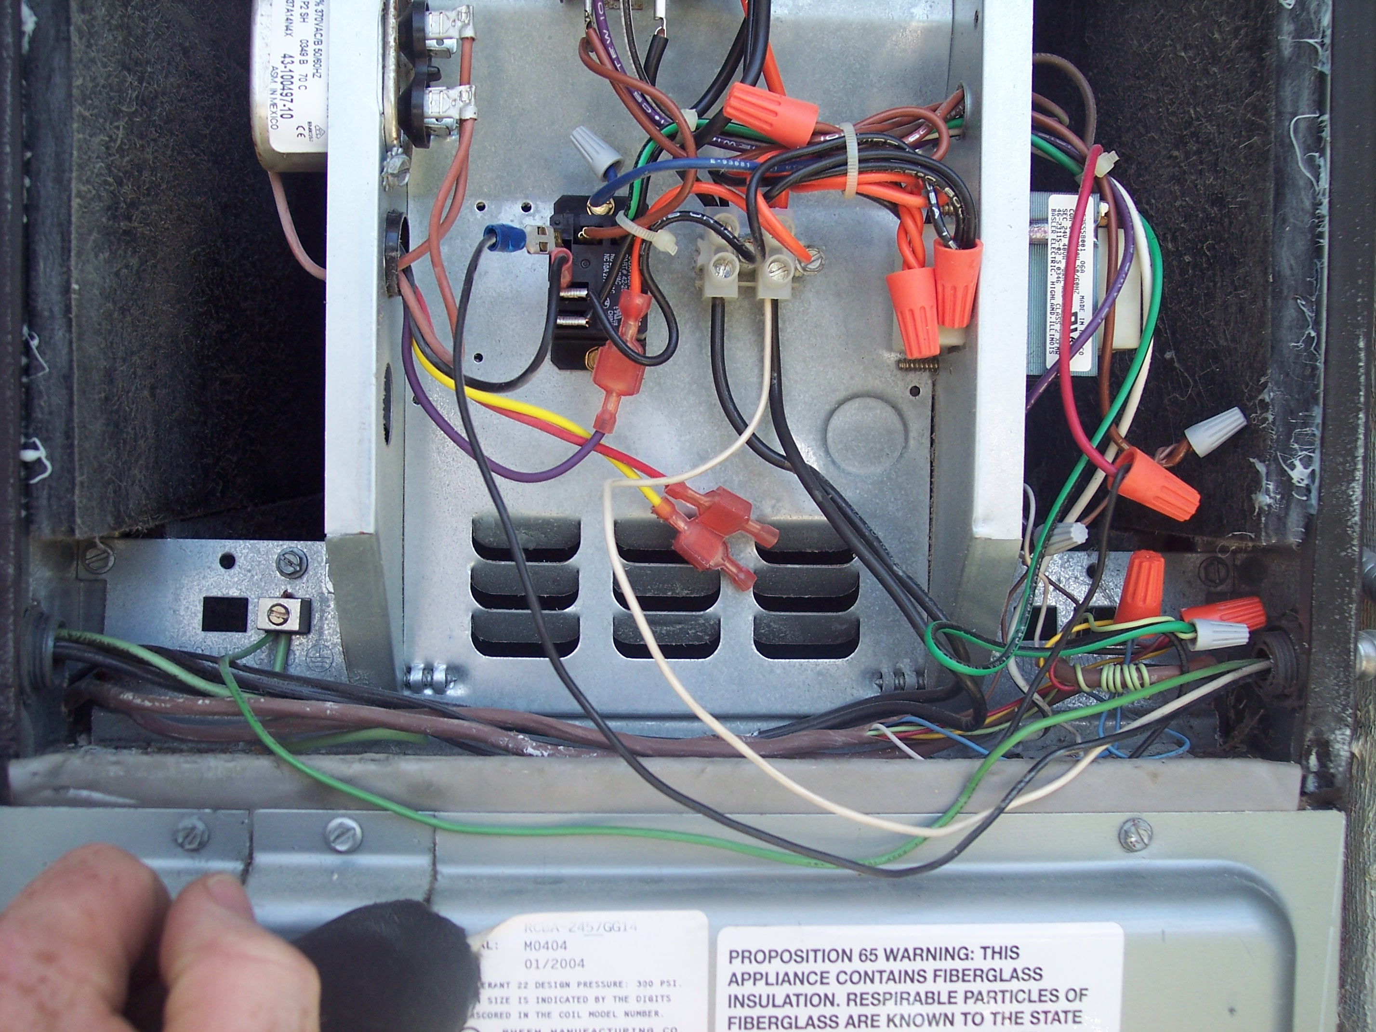
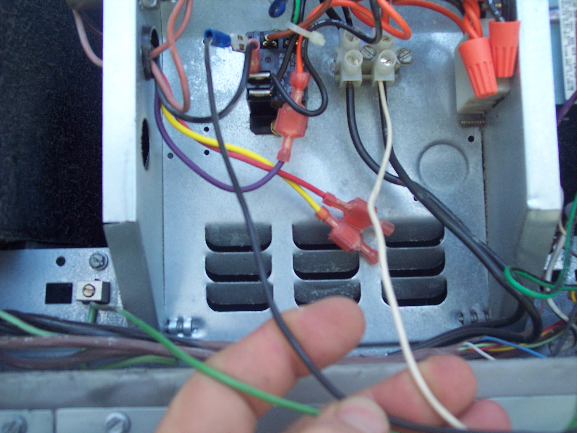
Exhibit A Exhibit B

