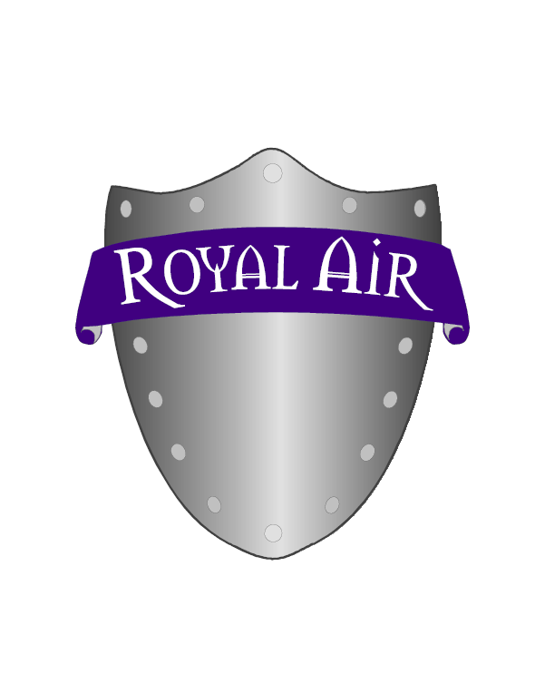

DISCLAIMER

CAUTION: The Royal Air Purifier may cause unprotected metals that are close to the unit to tarnish. We recommend a coat of spray Urethane varnish on bare metal surfaces to protect them. Aran may also cause natural rubber to degrade so keep your rubber bands in a sealable bag to protect them.

ROYAL AIR TROUBLE SHOOTING UPDATE
AND NOTES

Before going through the time, trouble and expense of returning a Royal Air Unit for repairs, please perform a thorough check keeping in mind the following points. If there is any doubt feel free to contact us before returning the Royal Air Unit.

Sometimes units that are functioning normally are returned to us for repairs. Check the basics first or walk your customer through it over the phone.

THINGS TO CHECK FIRST

- Is the plug securely plugged into a properly working electrical outlet of the correct voltage for the unit?
- Is the fuse blown? Fuse is located in the plug between the round grounded prong and the two “hot” rectangular metal prongs on face of the plug
- Is the Royal Air Unit turned on?

GAUGING ARAN OUTPUT BY THE HISSING SOUND

The hissing sound produced by the Royal Air Unit can be a good way to gauge its functioning, but remember the following when trying to determine if the output or performance of an Unit has changed significantly enough to warrant its return for servicing.

1. The hissing sound may be perceived to be, louder or softer than the norm, due to the noise level in the room.

2. The output of a certain model of Royal Air Purifier may vary from an identical unit due to normal variances in transformer outputs and other internal components supplied by our vendors.

