SECTION 1: TYPICAL APPLICATIONS

Stale Air; Odors; Smoke Odors; Pet Odors; Bacteria; Molds/Mildew; Cooking Odors; Chemical/Cleaning Material Odors; Restroom Odors; Closet Odors; Garage Odors; Floating Particulate; Dust; Pollen; many other offensive odors including garbage and sewage odors, etc.

SECTION 2: AIR PURIFIER SPECIFICATIONS

- Easy To Clean Durable Steel case
- Lightweight, compact and easy to carry
- Operates continuously 24 hours per day for less than 9 ¢
- Uses 120 VAC/60 Hz Current (about 25 watts) @ 1 amp

Physical Dimensions: 6" Width x 4.5 " High x 9 " Depth.
Weighs less than 11 pounds.

Output: 2590 mg/hr
Coverage: Up to 1,000 Sq. Ft. @ 8' ceiling

SECTION 3: PRE-INSTALLATION / INSPECTION

1. REMOVE UNIT FROM SHIPPING CARTON
2. INSPECT UNIT FOR ANY PHYSICAL DAMAGE
3. PLUG UNIT INTO 110VAC ELECTRICAL OUTLET having 3-prong receptacle.
(NOTE: Use an Adapter for two prongs to three prongs if this is the only option)
4. Occasionally unit may need cleaning from dust etc. Use Microfiber cleaning cloths

SECTION 4: PRINCIPALS OF OPERATION

The forces of Nature purify and cleanse outside air with ultra-violet sunrays, lightening and moisture. These forces bring the air cleansing action to the surface of the Earth. This process affects atmospheric contaminants and are either removed from the air by negative ionization which attracts them to the Earth's ground surfaces or are oxidized by the Super Oxygen created by the lightening. Oxidation is the chemical action of Oxygen combining with other materials, changing both the chemical and physical characteristics of that substance.

DISCLAIMER

CAUTION: The Air Purifier may cause unprotected metals that are close to the unit to tarnish. It is recommended a coat of spray Urethane varnish on bare metal surfaces to protect them. It may also cause natural rubber to degrade so keep your rubber bands in a sealable bag to protect them.

The Air Purifier electronically reproduces this natural phenomenon within any indoor environment. The Air Purifier does not create any artificial cleansing action. This electronic technology is designed to run continuously for many years. The Air Purifier re-establishes the freshness of air within the indoor environment and eliminates the needs of a filter in the machine.

There is no need to filter, chemically treat or dilute air with the Air Purifier. Air movement is important to the Unit to obtain maximum cleansing action. Since (O₄,O₅,O₆ etc) is heavier than normal Oxygen in the air, a cascading effect is normal and the unit should be placed on high shelving, refrigerator tops, mantels etc. in order to fully utilize this natural air movement. Always place the unit away from any cold air return ducts so that the (Super Oxygen) can pass through that area before exiting through the cold air ducts.

SECTION 5: AIR PURIFIER FEATURES

- Compact Lightweight & Portable
- No Filters to clean or replace
- No bulbs to replace
- Destroys mold, bacteria, viruses
- Removes dust, pollen from air
- Low cost to operate
- Made in USA

SECTION 6: PLACING THE AIR PURIFIER UNIT

Place the Air Purifier as high as possible in the room area you spend most of your time or where you wish to purify the air. On a bookcase, shelf, second floor, refrigerator top (at least six (6) feet from the ground). Many pollutants rise in the air and the Air Purifier needs to be higher than the pollutants so that the best results will occur throughout the entire room. This purifying effect will continue throughout your house if any of the unused Super Oxygen passes through the cold air return duct and is abundant enough to effect the other areas of your house.

The following suggestions will aid you in selecting a good location for your Air Purifier:

- Place the unit near the source of your worst odor.
- Place the unit centrally in an open area.
- In basement with mold and mildew problems.
- In a closet to freshen and deodorize your clothing.
- In a bathroom. (The Air Purifier is an electrical device. Don’t place unit near water or any place where it may come in contact with water!)
SECTION 7: MAINTENANCE

Unlike all other devices used to filter or clean air, the only maintenance required to keep your Air Purifier in excellent condition is to dust the unit occasionally when it may appear dusty.

While you may be dusting your furniture more often while using the Air Purifier, remember this: the dust that you are cleaning from the surfaces was once the dust and dirt that you would have been breathing! The particles that settle out of the air let you know that the Air Purifier is doing its job!

SECTION 8: TROUBLESHOOTING

If your unit is not operating, check the following:

1. Is the plug securely plugged into a properly working electrical outlet of the correct voltage for the unit?
2. Is the Electrical Outlet active?
3. Is the Fuse blown? Fuse is located in the plug between the round grounded prong and the two “hot” rectangular metal prongs on face of the plug

No attempt should be taken to open the unit if it appears to malfunction

GAUGING OUTPUT BY THE SOUND

The hissing sound produced by the Air Purifier can be a good way to gauge its functioning.

1. The hissing sound may be perceived to be louder or softer then the norm, due to the noise level in the room.
2. The output of a certain model may vary from an identical unit due to normal variances in the transformer outputs and other internal components.

CONTACT INFORMATION
For any further information or assistance, you may call:

PURE AIR FOR LIFE
P.O. BOX 360733
STRONGSVILLE, OH 44136
TEL: (216) 640-9710

INSTRUCTION MANUAL

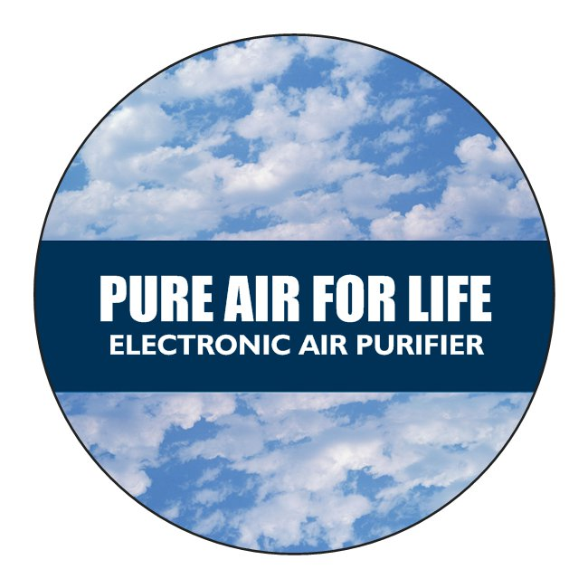

PLEASE READ INSTRUCTIONS PRIOR TO OPERATING

Pre-Operation Information
- Operation

Maintenance

TABLE OF CONTENTS

SECTION 1: APPLICATIONS
SECTION 2: SPECIFICATIONS
SECTION 3: PREINSTALLATION / INSPECTION
SECTION 4: PRINCIPALS OF OPERATION
SECTION 5: AIR PURIFIER FEATURES
SECTION 6: UNIT PLACEMENT
SECTION 7: MAINTENANCE
SECTION 8: TROUBLESHOOTING

CAUTION: CONNECT ONLY TO ALTERNATING CURRENT (AC): 110 VAC 60 Hz NEVER CONNECT TO DIRECT CURRENT (DC)!

